Name: Abdullah Chouhan

Roll no: 23L-0713

**Question 1:**

#include <iostream>

int main()

{

    int *speed = new int;

    double *travelTime = new double;

    double *distance;

    *speed = 65;

    *travelTime = 8.5;

    distance = new double;

    *distance = (*speed)*(*travelTime);

    std::cout << *distance << std::endl;

    delete speed, travelTime, distance;

    return 0;

}

**Output:**



**Question 2:**

#include <iostream>

void swapUsingPointers(int *a, int *b) {

    int temp = *a;

    *a = *b;

    *b = temp;

}

void swapUsingReferences(int &a, int &b) {

    int temp = a;

    a = b;

    b = temp;

}

int main() {

    int num1 = 10;

    int num2 = 20;

    std::cout << "Before swapping: num1 = " << num1 << ", num2 = " << num2 << '\n';

    swapUsingPointers(&num1, &num2);

    std::cout << "After pointer swapping: num1 = " << num1 << ", num2 = " << num2 << '\n';

    num1 = 10;

    num2 = 20;

    swapUsingReferences(num1, num2);

    std::cout << "After reference swapping: num1 = " << num1 << ", num2 = " << num2 << '\n';

    return 0;

}

**Output:**

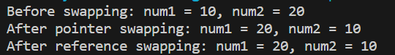

**Question 3:**

#include <iostream>

int main() {

    int arr[5];

    int* ptrarr = arr;

    int sum = 0;

    std::cout << "Input 5 values for array\n";

    for (int i = 0; i < 5; i++) {

        std::cin >> *(ptrarr + i);

        sum += *(ptrarr + i);

    }

    std::cout << "The sum of the values is " << sum;

    return 0;

}

**Output:**

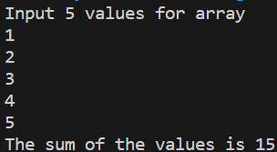

**Question 4:**

#include <iostream>

int main() {

    int size, search;

    std::cout << "Input array size: ";

    std::cin >> size;

    int *ptrarr = new int[size];

    std::cout << "Input " << size << " array values\n";

    for (int i = 0; i < size; i++)

        std::cin >> *(ptrarr + i);

    std::cout << "Input value to search for: ";

    std::cin >> search;

    for (int i = 0; i < size; i++) {

        if (search == *(ptrarr + i)) {

            std::cout << "Value found at index " << i;

            break;

        }

    }

    delete[] ptrarr;

    return 0;

}

**Output:**

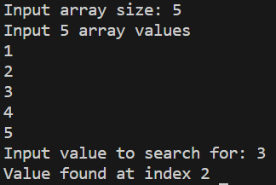

**Question 5:**

#include <iostream>

void reverseArray(int *arr, int size) {

    int temp;

    for (int i = 0; i < size / 2; i++)

    {

        temp = *(arr + i);

        *(arr + i) = *(arr + size - i - 1);

        *(arr + size - i - 1) = temp;

    }

}

int main() {

    int size, search;

    std::cout << "Input array size: ";

    std::cin >> size;

    int *ptrarr = new int[size];

    std::cout << "Input " << size << " array values\n";

    for (int i = 0; i < size; i++)

        std::cin >> *(ptrarr + i);

    reverseArray(ptrarr, size);

    std::cout << "Outputting reversed array\n";

    for (int i = 0; i < size; i++)

        std::cout << *(ptrarr + i) << '\n';

    delete[] ptrarr;

    return 0;

}

**Output:**

